Southern West Virginia Supplemental Questions
Do you identify as... *
- Born & Bred West Virginian!
- Raised but not born here and my Blood Runs Blue and Gold with WV Pride!
- Born in the Central Appalachian Coalfields (not-WV specific)
- Person With Family Working in the Chemical or Coal Industry
- Person Who Is Directly Impacted by Dirty Industry Pollution
- Other:
Do you have experience with community or student groups or organizations? Please describe. *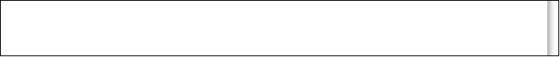

What experiences have you had in communities that are economically dependent on single industries (coal, chemicals, etc) and/or have been targets of social injustice? *

