Twin Cities, MN Supplemental Questions
Which of our project areas are you interested in participating in? *
- Urban farming
- Creating green industry with the ARISE coalition
- Building community power around clean energy and energy efficiency
- Helping kids bike to summer programming and/or helping with Learn to Ride a Bike classes
What is your relationship to our program area in South Minneapolis? *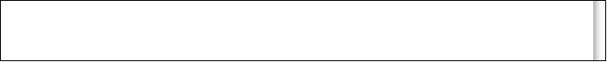

Are you interested in engaging with our program before the summer begins?
This is most important for helping to set up the garden before the program begins. Also, there is a class for people to become certified to lead bike rides that some of our program leaders will be attending -- if you are interested in attending and can pay the $200 registration fee, please email Ruby Levine ASAP at ruby.levine@gmail.com

Are you interested in continuing to work with our projects after the summer ends? *
This includes continuing to harvest in the garden, leading bike rides through the end of the summer, and continuing to engage with our energy and green manufacturing projects indefinitely.
- I absolutely plan to stay involved
- I want to continue to work in the garden after the program ends in mid August
- I want to continue helping with the bike rides for kids after the program ends in mid August until the kids go back to school
- I may stay involved past the summer, but I'm not sure
- I know for sure that I will not stay involved with the specific projects past the summer, but I will continue elsewhere and in other ways!
- Other:

